Strategy is how we communicate and give life to our vision, mission and values. If our strategy does not align with our vision, mission and values, it can lead to the company goals and overall objectives not being met. With an incorrect strategy, our vision, mission and values become only words and not actions, and our actions do not reflect our goals we envisioned initially, hence we end up not being able to achieve our goals we set out to achieve. Nortel declared bankruptcy in 2009 due to years of strategic misalignment (Heracleous & Werres, 2015). The value most misaligned with the strategy in my opinion was integrity, as mismanagement, recklessness and weak auditing contributed to a buildup of financial failures and a loss of staff morale over time.

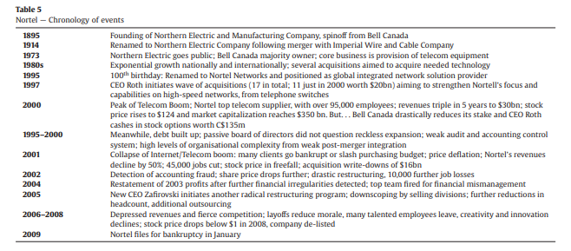

Leaders need to regularly review their strategic alignment and ensure that the company strategy and objectives match their values, vision and mission and recalculate their strategy if they see it does not. A simple way of doing this is through reflection, if the company has not achieved certain outcomes, find out why, and if misalignment may be the cause.

References:

Heracleous, L., & Werres, K. (2015). On the Road to Disaster: Strategic Misalignments and Corporate Failure. Long Range Planning, 9. <https://citeseerx.ist.psu.edu/viewdoc/download?doi=10.1.1.720.5962&rep=rep1&type=pdf>

Total Words (213)